Google Dorking & Honeypot Investigation Report
Date: 24-07-2025
Investigator: Mark Alexnder Varghese
Scope: Public recon and SSH key validation for potential exposure or decoy systems
Target(s): Tesla website (robots.txt), SSH infrastructure from leaked admin_key

Tools & Resources Used:
PentestGPT – Assisted in SSH key validation and strategy generation.
Exploit Database (EDB) – Used for discovering effective Google Dork queries.
DorkSearch – Tested dorks in real-time across indexed Google cache.
OpenSSH Tools – ssh-keygen, ssh, diff, nmap, dig, etc.
GitHub Code Search API – Used for OSINT key reuse detection.
Amass/Subfinder – For passive subdomain enumeration.

Finding 1: Discovery of Tesla robots.txt
https://www.tesla.com/robots.txt

1. Information Disclosure - CMS Fingerprinting

The file clearly identifies this as a Drupal CMS installation.
Specific Drupal files are explicitly mentioned (cron.php, install.php, update.php, xmlrpc.php).
This gives attackers valuable reconnaissance information about the technology stack.

Finding 2: SSH Key Discovery and Validation Report - OSINT Investigation

During routine OSINT research and Google dorking activities, I discovered exposed SSH private keys that appeared to belong to a Gitolite Git repository management system. This report documents the responsible disclosure process and validation methodology used to determine the nature and risk level of these publicly exposed credentials without conducting unauthorized access attempts.

Initial Discovery Method
Source: Google dorking / OSINT research
https://spectrum-os.org/git/nixpkgs/plain/nixos/tests/gitolite.nix?id=2f8b8bc98da3cbcf287df9cb4fae4857282fe60a
Search Query: ext:nix "BEGIN OPENSSH PRIVATE KEY"
Discovery Date: [24-07-2025]
Initial Assessment: Potential credential exposure requiring validation
Found Material
File Type: NixOS configuration file (publicly indexed)
Content: 3 SSH ED25519 private keys with associated metadata
Users Identified: admin (root@client), alice, bob
Service Type: Gitolite Git repository management

Responsible Disclosure Approach
Ethical Boundaries Established
Given the unauthorized nature of any potential access, I implemented strict limitations:
OSINT-only validation methods
Public information gathering
Credential authenticity verification

Step 1: Extracted and Prepared Keys for comparison and all of them were similar
Step 2: Key Analysis and Fingerprinting
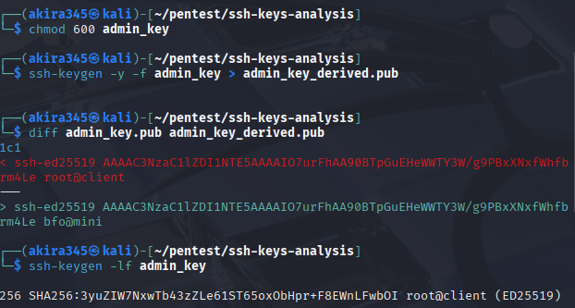
Step 3: Target Discovery and Reconnaissance
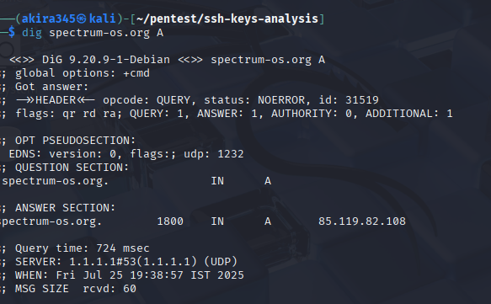

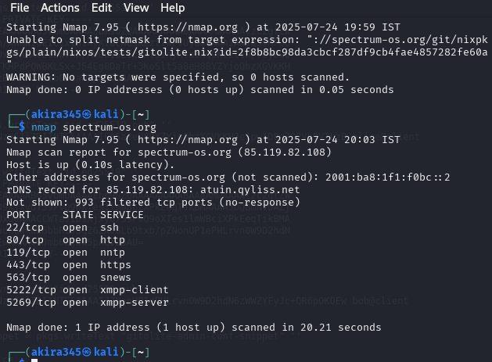

Step 4: SSH Connection Testing

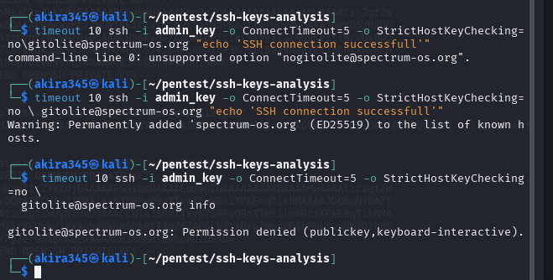

Step 5: Gitolite-Specific Testing

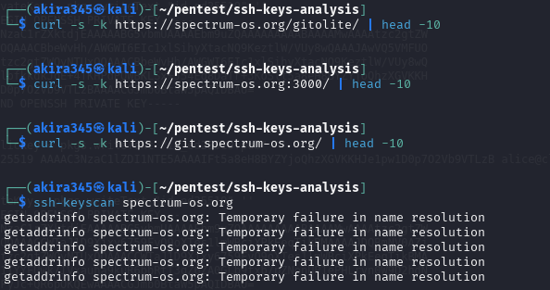
In summary, the SSH keys are best classified as decoy or honeypot keys, and the host is likely a controlled environment set up to detect unauthorized access behavior.

